**Study Guide to Homer’s *Odyssey***

**Stylistic Features**

**1. Repetition**

Consider the famous lines used to indicate the time of day: ‘But when the young Dawn showed again with her rosy fingers’. In all, about 1,000 of the *Odyssey*’s lines are repeated out of a total of 12,000.

2. **Similes**

The poet interrupts his narrative in order to develop an elaborate point of comparison for the thing he is describing. These similes are at times so extended that they constitute miniature narratives, embedded in the central one.

**The Homeric Question**

Opinion on the authorship of the two epics is divided. In antiquity, it was generally believed that they are the work of the same poet, but some scholars held that the *Odyssey* was composed by a different poet. The 1st century AD critic Longinus wrote that Homer

Made the whole body of the *Iliad*, which was written at the height of his powers, dramatic and exciting, whereas most of th*e Odyssey* consists of narrative, which is a characteristic of old age. Homer in the *Odyssey* maybe compared to the setting sun: the size remains without the force (Longinus 1965)

**How is the *Odyssey* different from the *Iliad* in its subject matter, scope, and construction?**

The *Iliad* deals with the wrath of Achilles, the greatest of the Greek warriors, whereas the *Odyssey* depicts the adventures of the homecoming Odysseus and the trouble confronted by his family in the aftermath of the Trojan War. If the former’s subject matter is martial prowess, and the deadly struggles between groups of great warriors, the latter focuses far more on the domestic lives of its characters, especially the homesick Odysseus. The *Odyssey*’s characters are more diverse—we encounter princess, monsters, nymphs and swineherds—whereas the *Iliad* relates only those who fight at Troy. In terms of construction, the *Iliad* is straightforward; the *Odyssey* is engagingly complicated:

Book 1-4: The Prince’s search for his father

Book 5-12: Odysseus’s retrospective account of his adventures

Book 13-24: Odysseus at Ithaca

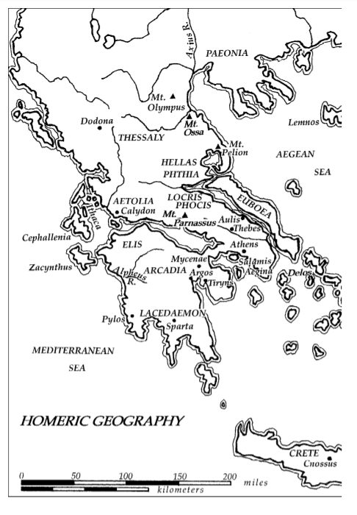

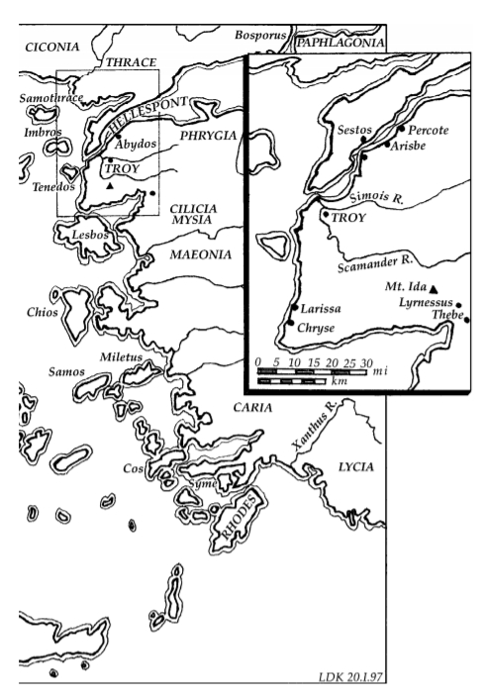

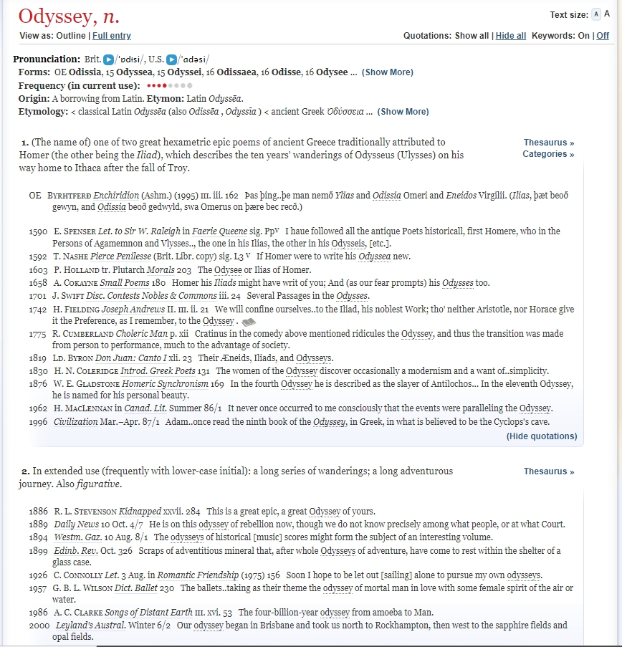

**Reading and Discussion Questions**

**Book 1 of the *Odyssey* (pp.291-301)**

‘you’ve got to stop

Acting like a child. You’ve outgrown that now.

Haven’t you heard now Orestes won glory

Throughout the world when he killed Aegisthus,

The shrewd traitor who murdered his father

You have to be aggressive, strong – look at how big

And well-built you are – so you will leave a good name.’ (Book 1, Il. 313-9)

‘A Son has many problems to face at home

When his father is gone and there is no one else

To help him’ (Book 4, ll. 170-3)

1. The epic begins with Homer’s invocation of the Muses (lines 1-10). Who is the hero? What kind of man is he? How is he different from the other Greek heroes? (ll. 13-27)

2. The Gods and Goddesses begin their meeting in the Olympus by relating Orestes’ slaying of Aegisthus, the lover of Agamemnon’s Wife, Clytemnestra (ll. 33-48). Read footnote 9 about the tragedy of Agamemnon (p. 292). How is this episode relevant to the main thrust of the *Odyssey*?

3. Why has Odysseus not returned home? Which God has he infuriated? Who speaks up for him in the Olympus? (ll. 49-68) What is the viewpoint of Zeus on this matter? (ll. 70-85)

4. In what form does Athena pay Telemachus a visit and communicate with him in the palace of Ithaca? Why? (ll. 103-113;192-229) How is she received by the prince (ll. 121-154)?

5. What kind of trouble is Telemachus confronted with in his palace? Is he able to address the problem? Why? (ll. 155-190; 250-269) Discuss the mixed feelings of Telemachus toward his long-absent father? Does he enjoy being the son of Odysseus? (ll. 230-237; )?

6. How does Athena inspire Telemachus? What is her advice for the prince? (ll. 270-322) Is it taken?

7. Who is Penelope? Why is she disturbed by the singing of a bard and tell him to change the song? Who is the signer? How does Telemachus respond to his mother’s request (ll. 346-384)?

8. How does Telemachus confront the suitors? What does he tell them about the news of his father and what he is going to do? What do we learn about the prince from the way he handles the suitors? (ll. 385-433)

Discussion Questions

1. What is the function of the story of Agamemnon and Aegisthus?
2. What is gained (and what is lost) by delaying Odysseus’ first appearance for so long? Why does Homer begin the narrative in Ithaca, and at this particular moment—twenty years, that is, after Odysseus’ departure for Troy?
3. What sort of narrative does the prologue lead us to expect?
4. Why does Athena choose to appear to Telemachus in disguise? Is there any purpose to the lies she tells him?

Book II (ll. 92-120, pp. 303-304)

‘Well, the big speaker, the mighty orator.

You’ve got some never, Telemachus,

Laying the blame on us. It’s not the suitors

Who are at fault, but your own mother,

Who knows more tricks than any woman alive.

It’s been three years now, almost four,

Since she’s been toying with our affections.

She encourages each man, leading us on,

Sending messages. But her mind is set elsewhere.

Here’s just one of the tricks she devised;

She set up a great loom in the main hall

And started weaving a sizable fabric

With a very fine thread, and she said to us:

‘Young men—my suitors, since Odysseus is dead—

Eager as you are to marry me, you must wait

Until I finish this robe—it would be a shame

To waste my spinning—a shroud for the hero

Laertes, when death’s doom lays him low.

I fear the Achaean women would reproach me

If he should lie in death shroudless for all his wealth.’

‘We were persuaded by this appeal to our honour.

Every day she would weave at the great loom,

And every night she would unweave by torchlight.

She fooled us for three years with her craft.

But in the fourth year, as the seasons rolled by,

One of her women who knew all about it

Told us, and we caught her unweaving

The gloried shroud. Then we forced her to finish it.

**Book 4 of the *Odyssey* (pp.324-338)**

‘I wept and wept as I sat on the sand, losing

All desire to live and see the light of the sun’ (ll. 567-8)

1. In this book, Telemachus visits the King and Queen of Sparta Menelaus and Helen in Lacedaemon to gather information about the whereabouts of Odysseus. Who is Peisistratus? Why is he traveling with Telemachus? What is going on when they arrive at the palace of Menelaus? (ll. 1-21)

2. How are Telemachus and Peisistratus treated by Menelaus? What do we learn about the ancient Greek culture of hospitality? (ll. 29-68)

3. As Telemachus observes the court of Menelaus, he is greatly impressed by the King’s riches. How does the Spartan King gain his wealth? How long does it take for him to return home after the fall of Troy? What does he say about his wealth in light of the loss of his brother and friends? Is he content with his life?

(ll. 73-115)

4. The meeting between the guests and hosts is turned into a very emotional one: ‘Argive Helen, a child of Zeus, wept; Telemachus wept/And Menelaus wept, the son of Atreus/Nor could Nestor’s son keep his eyes dry’ (ll. 192-195). What put tears in everyone’s eyes?

5. As Menelaus intends to stop everyone from crying by serving his guests dinner and talking about Odysseus with his guests next morning, Helen “threw a drug into the wine bowl/They were drinking from, a drug/That stilled all pain, quieted all anger/And brought forgetfulness of every ill’ (ll. 231-234). She then tells them a story involving Odysseus and herself during the final days of the Trojan War. Why do you think Helen take control of the situation and drug their wine before telling a tale of Odysseus? What do we learn about Helen and Odysseus from her story? (ll. 231-284)

6. Upon hearing Helen’s story, Menelaus tells another one which serves as a commentary on her role in the Trojan War. How does the story of Menelaus’ challenge Helen’s? One person mentioned by Menelaus is Deiphobus: ‘You came there then, with godlike Deiphobus’ (l. 293). What is Deiphobus? Can you explain the striking difference between their stories? Are they both true stories told from different perspectives or one of them is false? If yes, which one? (ll. 285-309)

7. Next morning, Menelaus relates how he makes his journey home. Describe the difficulties Menelaus encounters and how he succeeds in sailing home. Who comes to his rescue when he and his crew are stuck in a harbor of Egypt?

Who is Proteus, the Old Man of the Sea? What does Menelaus have to do to return home? (ll. 376-489)

8. Menelaus is saddened to learn that not all of his friends have returned home safe and sound. Who fails to make it home? (ll. 511-550) What have become of Ajax, Agamemnon, and Odysseus in the wake of the fall of Troy? (ll. 511-511-589)

9. Why is Menelaus ‘not destined to die’ (l. 591) and able to survive the journey home? (ll. 590-599)

**Discussion Questions:**

1. What is the function of storytelling in this book? How do the tales of Helen and Menelaus tell us about the husband and wife?
2. How would you characterize the relationship between Helen and Menelaus? How do the stories they tell Telemachus about Odysseus reveal their character and relationship?

**Book V Nymph and Shipwreck**

Calypso spoke, an immortal radiance upon her:

“Son of Laertes in the line of Zeus, my wily Odysseus,

Do you really want to go home to your beloved country

Right away? Now? Well, you still have my blessings.

But if you had any idea of all the pain *205*

You’re destined to suffer before getting home,

You’d stay here with me, deathless—

Think of it, Odysseus!—no matter how much

You missed your wife and wanted to see her again.

You spend all your daylight hours yearning for her. *210*

I don’t mind saying she’s not my equal

In beauty, no matter how you measure it.

Mortal beauty cannot compare with immortal.”

Odysseus, always thinking, answered her this way:

“Goddess and mistress, don’t be angry with me. *215*

I know very well that Penelope,

For all her virtues, would pale beside you.

She’s only human, and you are a goddess,

Eternally young. Still, I want to go back.

My heart aches for the day I return to my home. *220*

If some god hits me hard as I sail the deep purple,

I’ll weather it like the sea-bitten veteran I am.

God knows I’ve suffered and had my share of sorrows

In war and at sea. I can take more if I have to.”

**Book 8 of the *Odyssey* (pp.371-385)**

1. Where is Odysseus in this book? Who is the King? How do the King and people of this island treat Odysseus? Does the King pledge to assist Odysseus’s journey home? What events does he prepare to entertain his guest? Why does the King go to the trouble of helping Odysseus? (ll. 1-49)

2. How does Athena help Odysseus to “lay the groundwork for [his] trip home” (l. 9)? What has she done for him in this book?

3. “And summon the godlike singer of tales, Demodocus” (l. 45-46). Demoducs is the bard of King Alcinous. Throughout this book, he showcases his singing several times. How is he introduced in this book? How does Homer describe his talent of singing and physicality? What is the first song he sings? And what is Odysseus’ reaction to it? (ll. 45-106)

4. Alcinous hosts a series of games— athletic events/sports contests—for Odysseus. What is the purpose of these games? What games? Who win them? (ll. 107-145)

5. Who challenge/taunt Odysseus to take part in a game/sport? How does Odysseus respond and deal with the challenger? (ll.146-255) Does being a guest make it difficult for him to outperform the Phaecians? How does his speech/performance reveal his character? (ll. 146-247) Who intervenes to soften the tensions between Odysseus and his challengers? (ll. 256-275) Does Odysseus accept the young Phaecians’ apology? (ll. 400-460)

6. What song is it that Demodocus sings after the games? Can you think of the function of the song? (ll. 287-395) Compared the second song with the first one)

7. Who is Nausicaa? (l. 493)? Think about the implication of her speech and Odysseus’ reply.

Nausicaa:

“Farewell, stranger, and remember me

In your own native land. I saved your life” (ll. 498-499)

Odysseus:

“Nausica, daughter of great Alcinous

“So may Zeus, Hera’s thundering lord,

Grant that I see my homeland again.

There I will pray to you, as to a god,

All of my days, I owe you my life” (ll. 501-505)

8. Odysseus asks a herald to give Demodocus a cut of meat during the banquet. Why does Odysseus take a special interest in the bard? What song does Odysseus request? Why? (ll. 515-563) What is his reaction to the song? Analyze the epic simile Homer uses to describe Odysseus’ emotional response? (ll. 565-579)

9. Who notices the tears of Odysseus and stops the singing of Demodocus? (ll.575-632)

**Discussion Questions**

1. Examine the role of the bard in the *Odyssey*. What bards have we encountered in the books we read?

2. Discuss the function of songs in the Odyssey. What songs are sung by the Phaecian bard in this book?

3. Explore Homer’s narrative techniques in the *Odyssey*. For example, toward the end of book 8, Alcinous asks Odysseus a series of questions regarding his identity and adventures. These questions lead the Trojan hero to retell his wanderings immediately after the fall of Troy from book 9-13.

**Book 9 of the *Odyssey* (pp.385-397)**

‘Where should I begin, where end my story?’ (l. 15)

**In this book, Odysseus tells King Alcinous and the Phaecians of his harrowing journey, especially his encounter with the one-eyed, man-eating giant Polyphemus in the island of Cyclopes.**

1. Before narrating the pain and sorrow of his wanderings in the wake of the Trojan War, what does Odysseus tell Alicious first? Why? What is his native land Ithaca like? To the war hero, what ‘is the finest thing in the world’? (ll. 1-30)? Why?

2. Who are Calypso and Circe? (Odysseus’ encounter with them can be found in book 5 and 10; if you have time, read pp. 346-349 and pp. 406-410) What do they want from Odysseus? Why do they fail to persuade him and touch his heart? (ll. 30-42)?

3. What kind of trouble does Odysseus have in Ismaros (ll. 42-43) and the land of the Lotus-Eaters respectively? (ll. 42-101) What do both misadventures tell the kind of obstacles and challenges Odysseus face in bringing his men home safe and sound?

4. What is the island of the Cyclopes like? What is special about this island and its inhabitants? How do Odysseus and his men end up in it? (ll. 102-137)?

5. Why does Odysseus want to see and confront the Cyclopes? Before setting off, he has ‘a strong premonition’ that he is going to meet ‘[a] savage with no notion of right and wrong’. (ll. 204-205)? Then, he disregards the suggestion of his men that they leave the Cyclops’ cave with cheese because he wants to ‘see him, and see if he would give me a gift of hospitality’ (ll. 228-230). What is on the mind of Odysseus? What does his consideration tell us about him as a hero/leader? What does it imply when he comments retrospectively that ‘it would have far better if [he] had’ listened to his comrades (ll.218-9) ?

6. What happens when Polyphemus returns and finds Odysseus and his men in the cave? (ll. 221-299) Does the way the monster treats them take Odysseus by surprise? Why does he ask Odysseus where their ship is left? (ll 270-273)? What does Odysseus say? Why stops him from killing Polyphemus?

7. How does Odysseus defeat Polyphemus and escape the cave? (ll. 311-405) Does his plan work out? Why does he tell the monster that his name is ‘noman’?

8. Having made it back to the ship, Odysseus could have left the island behind in quiet. However, in spite of the protests of his comrades, he taunts Polyphemus by shouting out his real name and his identity. Why does Odysseus feel the need to do this? What does this reveal about the character of Odysseus? What does the Cyclops pray after learning of who Odysseus is? How does this impinge on his journey home? (ll. 475-560)

**Discussion Questions**

How does the shift from third-person to first-person narration affect the way we interpret the narrative in this book?

What justifications does Odysseus give for his behavior toward Polyphemus?

Examine the importance of name/deception in book 8 and 9 of the *Odyssey*. In both books Odysseus reveals his name after a long delay. Why does he conceal his name for so long in each case? What effect does it have when he reveals it?

**Book X The Bewitching Queen of Aeaaea**

**(lines 471-95, pp. 407-8)**

Meanwhile, back in Circe’s house, the goddess

Had my men bathed, rubbed down with oil,

And clothed in tunics and fleecy cloaks.

We found them feasting well in her halls.

When they recognized each other, they wept openly

And their cries echoed throughout Circe’s house.

Then the shining goddess stood near me and said:

‘Lament no more. I myself know

All that you have suffered on the teeming sea

And the losses on land at your enemies’ hands.

Now you must eat, drink wine, and restore the spirit

You had when you left your own native land,

Your rugged Ithaca. You are skin and bones now

And hollow inside. All you can think of

Is your hard wandering, no joy in your heart,

For you have, indeed suffered many woes.’

She spoke, and I took her words to heart.

So we sat there day after day for a year,

Feasting on abundant meat and sweet wine.

But when a year had passed, and the seasons turned,

And the moons waned and the long days were done,

My trusty crew called me out and said:

‘Good god, man, at long last remember your home,

It is heaven’s will for you to be saved

And return to your house and your own native land.’

**Book XIII of the *Odyssey*: Ithaca at Last**

**Athena’s commentary on the craftiness of Odysseus (lines 194-197, 208-215, 295-310, pp. 443-444)**

Odysseus, meanwhile,

Awoke from sleep in his ancestral land—

And did not recognize it. He had been gone so long,

And Pallas Athena had spread haze all around.

……………………………………………………..

‘What land have I come to now? Who knows

What kind of people live here—lawless savages,

Or godfearing men who take kindly to strangers?

Where am I going to take all these things? Where

Am I going to go myself? I should have stayed

With the Phaeacians until I could go on from there

To some other powerful king who would have

Entertained me and sent me off homeward bound.

------------------------------------------------------------

Athena smiled at him, her eyes blue as the sea,

And her hand brushed his cheek. She was now

A tall, beautiful woman, with an exquisite touch

For handiwork, and her words had wings:

“Only a master thief, a real con artist,

Could match your tricks—even a god

Might come up short. You wily bastard,

You cunning, elusive, habitual liar!

Even in your own land you weren’t about

To give up the stories and sly deceits

That are so much a part of you.

Never mind about that though. Here we are,

The two shrewdest minds in the universe,

You far and away the best man on earth

In plotting strategies, and I famed among gods

For my clever schemes.

**Book 22: Slaughter in the House (pp.545-559)**

As Odysseus has been warned that his palace is plagued by suitors wooing his wife and devouring his goods, he disguises himself as a beggar on his return to Ithaca (which happens in book 13). He reveals his identity only to the swineherd Eumaeus (his encounter with Odysseus is told in book 14), the cowherd Philoetius, his son Telemachus (the reunion of the father and son is told in book 15), and the old nurse Eurycleia (she is first introduced toward the end of book 1 as ‘true-hearted Eurycleia’ on page 301, line 451). These four people play different yet crucial roles in assisting Odysseus’ slaying of the suitors in book 23:

“…so they took their stand

There on the threshold, breathing fury,

Four of them against the many who stood in the hall” (ll. 212-214)

In book 21, Penelope announces to the suitors an archery contest to decide who is going to be her husband: whoever can string the bow of Odysseus and shoot an arrow through twelve axes will be the man.

“Hear me, proud suitors. You have used this house

For an eternity now—to eat and drink

In its master’s absence, nor could you offer

Any excuse your lust to marry me.

Well, your prize is here, and this is the contest.

I set before you the great bow of godlike Odysseus.

Whoever bends this bow and slips the strong on its notch

And shoots an arrow through all twelve axes,

With him will I go, leaving behind this house

I was married in, this beautiful, prosperous house,

Which I will remember always, even in my dreams” (p. 537, lines 66-76)

Book 21 ends when every suitor tries and fails to win the contest, Odysseus easily strings the bow and shoots an arrow cutting through the aligned holes of the twelve ax heads

“Thus the suitors, while Odysseus, deep in thought,

Was looking over his bow. And then, effortlessly,

*Like a musician stretching a strong*

*Over a new peg on his lyre, and making*

*The twisted sheep-gut fast at either end,*

Odysseus strung the great bow. Lifting it up,

He plucked the strong, and it sang beautifully

Under his touch, with a note like a swallow’s” (ll. 430-37, pp. 545-46)

1. At whom does Odysseus let fly his first arrow from his bow? Why? (ll. 8-22) When does Odysseus reveal his identity and how? What’s the reaction of the suitors before and after they learn the King has returned? (ll. 22-44)

2. Who begs Odysseus to spare their lives and promise a handsome payment to make up for the suitors’ wrongdoings? How does Odysseus respond? Is he justified in killing all the suitors? (ll. 45-82) What happens to this suitor? (ll. 82-92)

3. How does Telemachus help Odysseus fight the suitors? What is he concerned about? (ll. 95-129)

4. What does Agelaus call on the suitors to do? His suggestion is rejected by the goatherd Melanthis, who proposes a different plan. Why? (ll. 135-17)

5. In the midst of war, why does “Odysseus’ heart sank, and his knees grew weak?” (l. 153)? How does he and his helpers deal with the crisis? What do they do to Melanthis during and after the fight? (ll. 153-208; ll.498-502 )

6. Who does Athena disguise herself as when Odysseus is fighting the suitors? Why does the Goddess hold back from helping the hero and his men when they engage in combat with the suitors and are in need of her help? For instance, “she did not yet/Give Odysseus the strength to turn the tide/She was still testing him, and his glorious son/To see what they were made of”/ (ll. 250-253). It is not until line 315 that we are told “only then/Did Athena hold up her overpowering aegis/From her high perch, and the minds of the suitors/Shriveled with fear, and they fled through the hall (ll. 315-318). Rather than wielding her power to aid Odysseus’ defeat of the suitors immediately and easily, Athena gives Odysseus a stirring speech, challenging him to be the Greek hero who fought in the Trojan War (ll. 239-255). Why? Why does Athena let the hero fight his own battle only help them indirectly? (She does make the suitors miss “their shots”; l. 272).

7. The soothsayer Leodes and the bard Phemius alike supplicate Odysseus by his knees. Examine their speeches and consider why Odysseus kills one and spares the other’s life (ll. 332-379) Who else does Odysseus spare his life? Why? (ll. 385-407)

8. Why does Odysseus summon the nurse Eurycleia? And what is the first and last thing he wants her to do for him? (ll. 417-515)

Discussion Questions:

1. How does Odysseus the cunning hero slay the suitors? What tactics does he use?

2. Discuss Homer’s use of the following epic simile in depicting the death of the suitors. What effects does it achieve?

“ *like fish that fishermen*

*Have drawn up in nets from the grey sea*

*Onto the curved shore. They lie all in heaps*

*On the sand beach, longing for the salt waves,*

*And the blazing sun drains their life away*.

So too the suitors, lying in heaps. (ll.409-414)

“

**Book 23 of Homer’s *Odyssey***

1. What kind of woman is Penelope? What has she been doing while Odysseus is away and has come back as a beggar in Ithaca? What epithets does Homer use to describe Penelope?

2. As Odysseus asks the old nurse Eurycleia to bring Penelope to the hall of the palace, the wife receives the nurse’s account—her long-absent husband has returned and miraculously killed all the suitors—with skepticism (ll. 1-88). Can you think of any reasons why Penelope refuses to believe in the nurse’s story?

3. As Penelope enters the hall and greets Odysseus with an awkward silence, what does the son Telemachus say? How does Penelope explain her silence? How does Odysseus respond? (ll. 101-120)

4. Read closely lines 171-215, and consider: why Penelope tricks Odysseus in this way? What does this tell us about Penelope and their relationship?

5. How does Penelope explain her failure to recognize Odysseus? (ll. 216-237)

6. After their reunion, do Penelope and Odysseus live happily ever after? Why does Odysseus tell her that “We have not come to the end of our trials”? (l. 255)

Discussion Questions

1. What similarities are there between Odysseus and Penelope? How are they shown to be well-matched?
2. Examine Penelope’s conversation with the old nurse and Odysseus in Book 23 carefully. At what point does Penelope recognize Odysseus? Try to back up your claim/interpretation by analyzing the textual evidence.

Group Activity 1

Margaret Atwood’s *Penelopiad* (2005) tells the story of the Odyssey from Penelope’s perspective. Consider a brief extract from her account of the events of book 23:

The hardness of my heart was a notion I was glad to foster, however, as it would reassure Odysseus to know that I hadn’t been throwing myself into the arms of every man who’d turned up claiming to be him. So I looked at him blankly, and said it was too much for me to swallow, the idea that this dirty, blood-stained vagabond was the same as my fine husband who had sailed away, so beautifully dressed, twenty years ago.

Odysseus grinned—he was looking forward to the big revelation scene, the part where I would say, ‘It was you all along! What a terrific disguise!’ and throw my arms around his neck. Then he went off to take a much-needed bath. When he came back in clean clothes, smelling a good deal better than when he’d gone, I couldn’t resist teasing him one last time. I ordered Eurycleia to move the bed outside the bedroom of Odysseus, and to make it up for the stranger.

You’ll recall that one post of this bed was carved from a tree still rooted in the ground. Nobody knew about it except Odysseus, myself, and my maid Actoris, from Sparta, who by that time was long dead.

Assuming that someone had cut through his cherished bedpost, Odysseus lost his temper at once. Only then did I relent, and go through the business of recognising him. I shed a satisfactory number of tears, and embraced him, and claimed that he’d passed the bedpost test, and that I was now convinced (pp. 169-71)

Is this passage compatible with your reading of Book 23? Can you find passage which either support or weaken Atwood’s view of Penelope?